Book List
LGBTQ Young Adult Fiction
(sexual orientation focus)

Title | Author
Boy Meets Boy | David Levithan
Ash | Malinda Lo
Hero | Perry Moore
The Vast Fields of Ordinary | Nick Burd
Geography Club | Brent Hartinger
Not Your Sidekick | C. B. Lee
Not Otherwise Specified | Hannah Moskowitz
Will Grayson, Will Grayson | David Levithan and John Green
What We Left Behind | Robin Talley
I’ll Give You The Sun | Jandy Nelson
Simon vs The Homo Sapiens Agenda | Becky Albertalli
She Loves You, She Loves You Not | Julie Ann Peters
Aristotle and Dante Discover The Secrets of the Universe | Benjamin Alire Saenz
One Man Guy | Michael Barakiva
Love in the Time of Global Warming | Francesa Lia Block
Two Boys Kissing | David Levithan
We Are The Ants | Shaun David Hutchinson
Of Fire And Stars | Audrey Coulthurst
Juliet Takes a Breath | Gabby Rivera
Girl Mans Up | M-E Girard
Way To Go | Tom Ryan
One Boy’s Shadow | Ross McCoubrey
Strong Hollow | Linda Little
Graphic Novels
Flutter | Jennie Wood
Drama | Raina Telgemeier
Runaways | Brian K. Vaughn
Beyond: A Queer Sci-Fi and Fantasy Anthology | Taneka Stotts & Sfe R. Monster
The Lumberjanes series | Noelle Stevenson

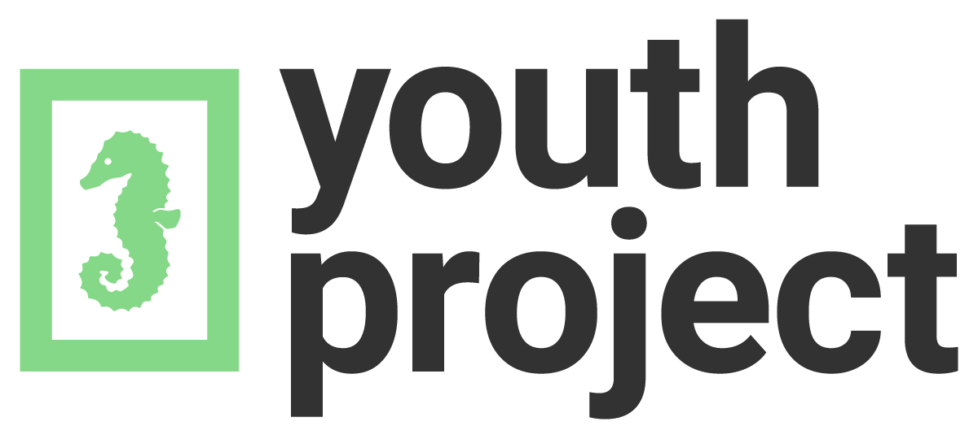
www.youthproject.ns.ca
902-429-5429

