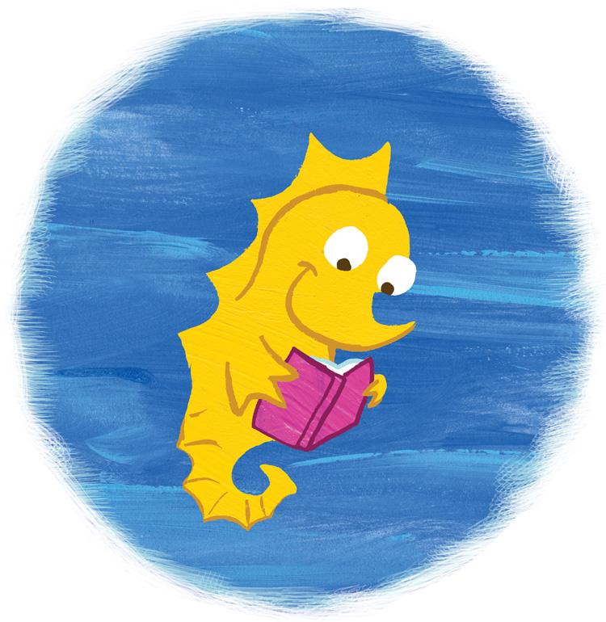

Book List
LGBTQ+ Support & Health Information for Youth

Youth/Young Adult, Non-Fiction & Support:

Queer: The Ultimate LGBT Guide for Teens by Kathy Belge (Author), Marke Bieschke (Author),

This Book is Gay by Juno Dawson & David Levithan
- GLBTQ: The Survival Guide for Gay, Lesbian, Bisexual, Transgender, and Questioning Teens (Revised & Updated Second Edition) by Kelly Huegel
- The Social Justice Advocate's Handbook: A Guide to Gender by Sam Killermann
- Homophobia: Deal With it & Turn Prejudice Into Pride by Steven Soloman
- Transphobia: Deal With it & Be a Gender Transcender by J Wallace Skelton
- The Gender Book by Mel Reiff Hill, Jay Mays, Robin Mack. Free download at http://www.thegenderbook.com/

Health:

Trans Bodies, Trans Selves: A Resource for the Transgender Community by Laura Erickson-Schroth (Ed)

You & Your Gender Identity by Dara Fox

The Gender Quest Workbook for Teens & Young Adults by Testa, Coolheart & Pita

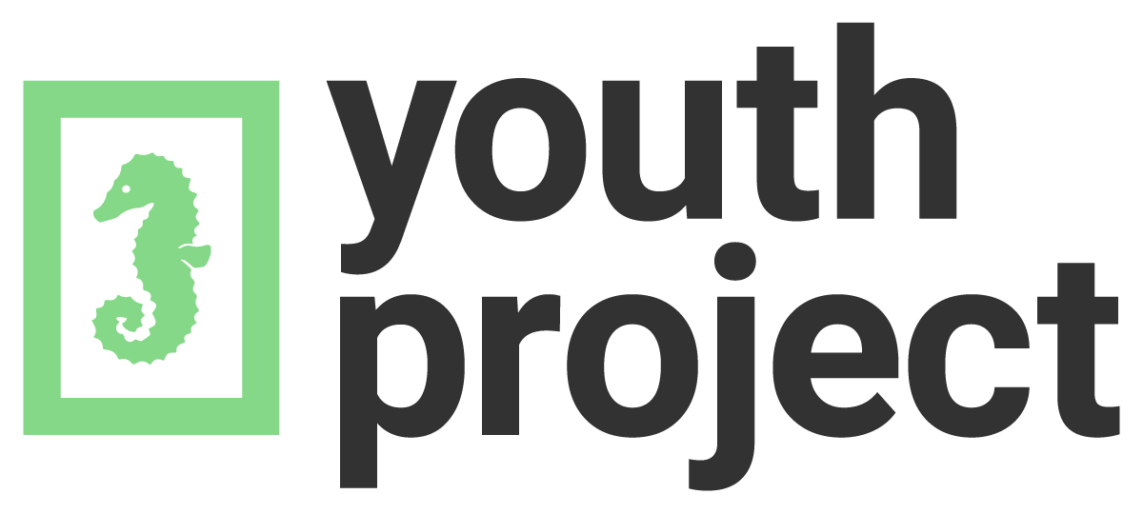
www.youthproject.ns.ca
902-429-5429

