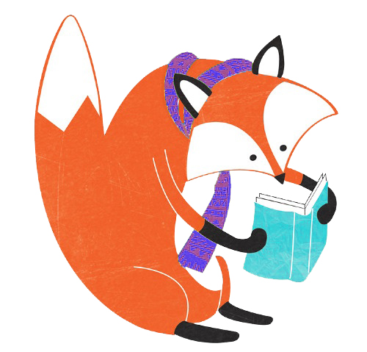
Book List
LGBTQ Young Adult Fiction
(gender identity focus)

Title Author
I Am J | Cris Beam
Beautiful Music for Ugly Children | Kirstin Cronn-Mills
If I Was Your Girl | Meredith Russo
Jess, Chunk and the Road Trip to Infinity | Kristin Clark
Lily and Dunkin | Donna Gephart
The Other Boy | M. G. Hennessey and Sfe R. Monster
Hello, Cruel World: 101 Alternatives to Suicide for Teens, Freaks and Other Outlaws | Kate Bornstein
Being Emily | Rachel Gold
Freakboy | Kristin Elizabeth Clark
First Spring Grass Fire | Rae Spoon
Every Day | David Levithan
If You Believe in Mermaids, Don’t Tell | AA Phillips
Lizard Radio | Pat Shmatz
One in Every Crowd | Ivan Coyote
Luna | Julie Anne Peters
Parrotfish | Ellen Wittlinger
George | Alex Gino
The Art of Being Normal | Lisa Williamson
The Symptoms of Being Human | Jeff Garvin
Gracefully Grayson | Ami Polonsky
Dreadnought (Nemesis Series #1) | April Daniels
When the Moon was Ours | Anne-Marie McLemore
Not Your Villain | C.B. Lee
Graphic Novels
Wandering Son | Takako Shimura
The Lumberjanes series | Noelle Stevenson
Beyond: A Sci-Fi & Fantasy Anthology | Ed. Tamika Stotts and Sfe R. Monster
A + E 4Ever | I. Merey

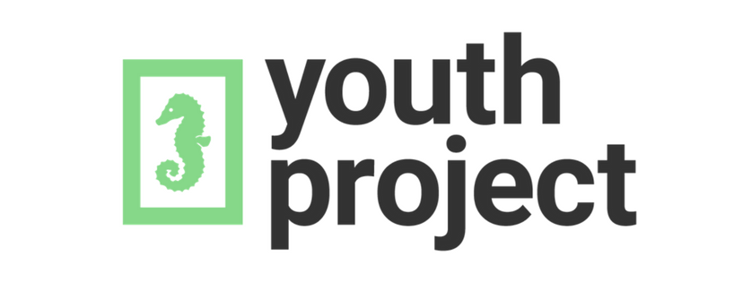
www.youthproject.ns.ca
902-429-5429

