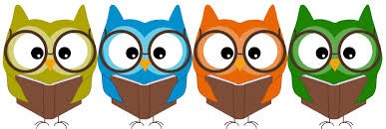

LGBTQ+ Book List
For children & families

Re: LGBTQ Families & Diversity

And Tango Makes Three by Justin Richardson

Worm Loves Worm by J. J. Austrian (Author), Mike Curato (Illustrator)

Stella Brings The Family by Miriam B. Schiffer

King & King Linda De Haan and Stern Nijland

This Day in June by Gayle E. Pitman

Donovan’s Big Day by Leslea Newman

The Boy Who Cried Fabulous by Leslea Newman

Mommy, Mama and Me by Leslea Newman

Daddy, Papa and Me by Leslea Newman

Elmer by David McKee

The Sissy Duckling by Harvey Fierstein

The Answer (Steven Universe picture book) by Rebecca Sugar

Re: Gender Identity & Expression

I Am Jazz by Jessica Herthel and Jazz Jennings

Backwards Day by S. Bear Bergman

The Adventures of Tulip, Birthday Wish Fairy by S. Bear Bergman

William’s Doll by Charlotte Zolotow

My Princess Boy by Cheryl Kilodavis
- Morris Micklewhite and the Tangerine Dress by Christine Baldacchino
- 10,000 Dresses by Marcus Ewert

Introducing Teddy by Jessica Walton

Red: A Crayon’s Story by Michael Hall

Jacob’s New Dress by Sarah Hoffman

When Kathy is Keith by Wallace Wong

Children’s Non-Fiction:

What Makes a Baby? by Cory Silverberg

Who Are You? The Kids Guide to Gender Identity by Brook Pessin-Whedbee (Auth.)

Parts and Hearts: A Kids (and Grown-Ups) Guide to Transgender Transition by Jenson J Hillenbrand

M is for Mustache by Catharine Hernandez

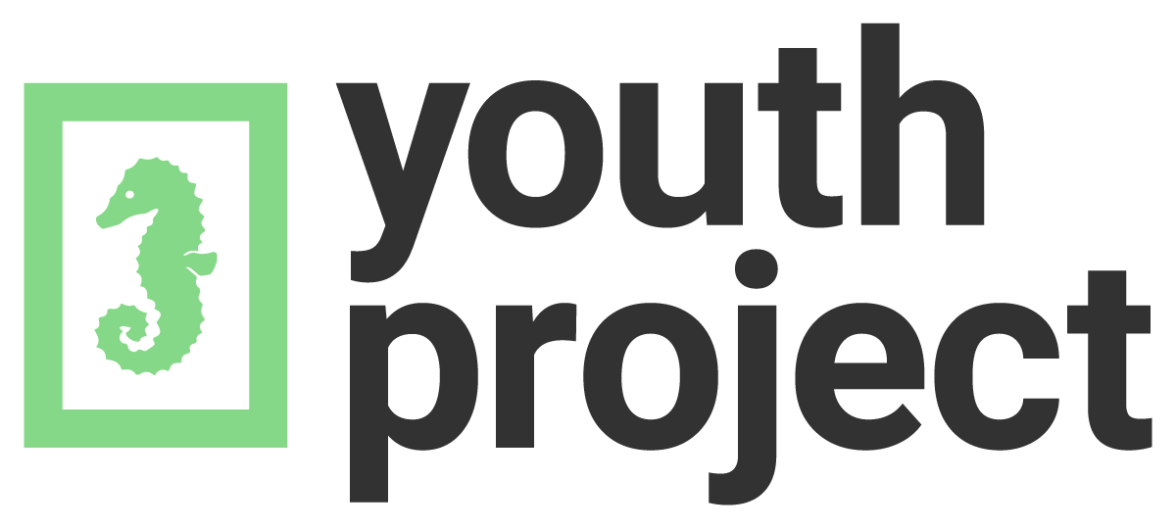
A is for Activist by Innosanto Nagara

