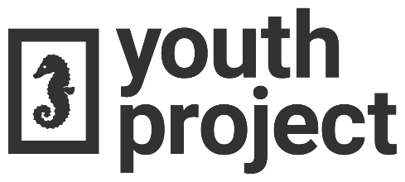
Media Wavier

I _________________________ give permission for The Youth Project to take photographs, video, or film of myself, either individually, or within a group. These photographs, film, or video, may be used for possible newsletters, reports, scrapbooks, displays, and posted on social media or on The Youth Project’s website.
They may also be used for promotional purposes by the media or financial supporters.
By signing below I give permission to use any photos, videos, or film for these purposes.
A guardian must also sign if under 19.

Date: _________________
Participant Name (Please Print): ________________________
Participant Signature: ________________________________
Parent/Guardian Signature: ___________________________
Contact Information (E-mail or Phone): __________________

